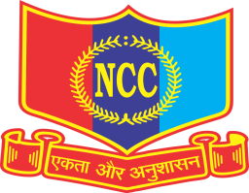 | (पीएमश्री केंद्रीय विद्यालय कठुआ)  PM SHRI KENDRIYA VIDYALAYA KATHUA  जन्ग्लोत रोड, नजदीकआर्मी कैंट कठुआ ( १८४१०४)  Janglote Road, Near Army Cantt. Area Kathua-184104(J&K)  Website:www.kathua.kvs.ac.in,Email:kvkathua2003@gmail.com,  CBSE Affiliation No. 700026,CBSE School Code:-24941  Region Code:-14,KV code:-1684,Station Code:-378,  UDISE: - 01140503420, 4th J & K BATALLION, NCC, JAMMU.
Vacancy Position
As per KVS Admission Guidelines 2024-25, following is the status of the vacancy position in Class II to IX for fresh Admissions in PM SHRI Kendriya Vidyalaya Kathua:

CLASS | VACANCY
II | NIL
III | NIL
IV | NIL
V | NIL
VI | NIL
VII | NIL
VIII | NIL
IX | NIL

PRINCIPAL

