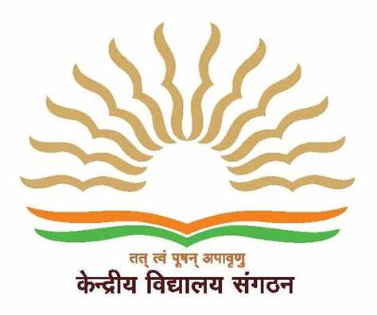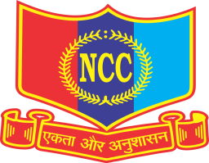 | KENDRIYA VIDYALAYA KATHUA (केंद्रीय विद्यालय कठुआ)  Janglote Road, Near Army Cantt. Area Kathua-184104(J&K)  जन्ग्लोत रोड, नजदीक आर्मी कैंट कठुआ ( १८४१०४)  Website:-www.kathua.kvs.ac.in,Email:kvkathua2003@gmail.com,  CBSE Affiliation No. 700026,CBSE School Code:-24941  Region Code:-14,KV code:-1684,Station Code:-378,  UDISE :- 01140503420  4th J & K BATALLION, NCC, JAMMU. | 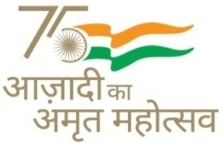
EDUCATION QUALIFICATIONS FOR TEACHERS AND CAREGIVERS (HELPERS) FOR BALVATIKA-3
Ref No: F.No.11331/2023-24/KVS (HQ)/ DC (Acad-II) Date 04.07.2023

- Qualification for Balvatika Teachers as prescribed by NCTE is given below:

- Senior Secondary class (Class XII or its equivalent) from a recognized Board with at least 50% marks
and
- Diploma in nursery Teacher education /Pre -school Education /Early Childhood Education Programme (D.E.C.Ed) of duration of not less than two years or B.Ed (Nursery) from NCTE recognized institutions.

- Qualification for caregiver or helper shall be as prescribed by NCERT/ NCPCR.

- Secondary class (Class X or its equivalent) from a recognized board, minimum 18 years of age and should have induction training in preschool Education. Or any person possessing skill training / adequate training as prescribed by NIPCCD, NSDC or any other institution recognized by the central Government/ appropriate Government/ Recognized University /Board.

Principal

