**KENDRIYA VIDYALAYA KATHUA** 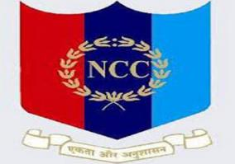

**Admission Notice 2023-24**

Balvatika is starting in Kendriya Vidyalaya Kathua from session (2023-24).Children of the age 5+ years but not have completed 6 years of age as on 31 March 2023 can apply for it. Registration for admission in Balvatika will be done through online mode. The link for registration will be available on KV Kathua website https://kathua.kvs.ac.in/. Interested parents can apply online from 06.07.2023 to 18.07.2023.

All the admissions will be done according to KVS Admission Guidelines (2023-24)

Principal

KV KATHUA